Script 1:

1. Retrieve a list of instances running in a specific AWS region.

2. Filter the instances based on their names.

3. Stop the matching instances.

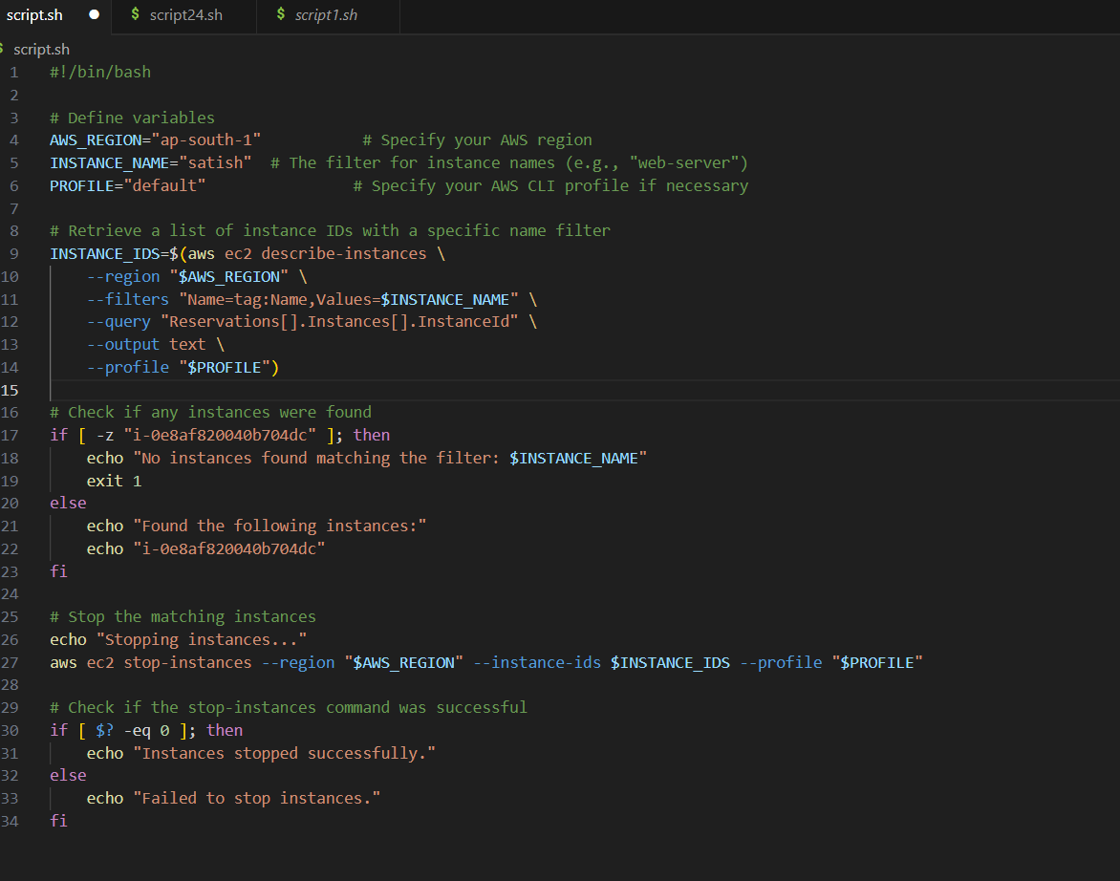

Output:

